Primary Sources and Transcriptions

# Description

This packet includes 4 primary source documents and their transcriptions (when needed) for the lesson plan “Black Resistance through Election Day.”

# Table of Contents

1741 Diary of Benjamin Lynde

1768 Petition to Salem Selectmen

1788 Diary of William Pynchon

1817 Diary of William Bentley

# Transcription Guidelines

When transcribing the handwritten document, the overall goals were to (1) make the text more readable and understandable for the audience and (2) to keep as much of the original text as possible. Some documents contain text that is not relevant to the lesson. On these documents, the relevant parts are highlighted in yellow.

# Donor Recognition and Thank You

This program was made possible by a grant from the National Park Foundation through the generous support of Union Pacific Railroad and donors across the country. Special thank you to The Phillips Library, Peabody Essex Museum, The Hard History Project, and the Lynn, Salem, and Saugus Public Schools.

Diary of Benjamin Lynde

May 27, 1741

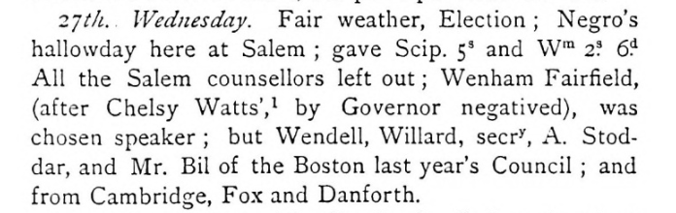

*Note:* “gave Scip. 5s and Wm 2.s 6.d” means that he (Lynde) gave two enslaved people money to celebrate Election Day. Scipio received 5 shillings and William received 2 shillings and 6 pence. Shillings and pence are British forms of money that were in use at that time in the British American colonies.

Citation and Credit: Lynde, B., Oliver, F. E. (Fitch Edward)., Lynde, B. (1880). *The diaries of Benjamin Lynde and of Benjamin Lynde, Jr..* Boston: Priv. print. [Cambridge, Riverside Press], 109. (https://hdl.handle.net/2027/hvd.32044029902830)

Salem Town Records

May 5, 1768

Also the Petition of said Peter Frye Esq. & others, Inhabitants of this Town, showing that great disorders usually happen among us on Election days by Negros assembling together, beating Drums & making use of powder with firing of Guns etc., etc., etc. & some have heretofore appeared on such days with Swords on, all which they the Petitioners think of Bad Tendency and therefore praying that it may be known of the Town will obtain a By Law to regulate those matters or consider some other method to prevent (for the future) the appearance of such disorders in the Town.

*Note:* The Petition was signed by the following: Peter Frye, Samuel Barton, Junior, Joshua Grant, George Crowninshield, Hasket Derby, Jonathan Andrews, Thomas Mason, John Prince, Ebenezer Bickford

The response from the Selectmen:

On reading and considering the petition of Peter Frye Esq. & others of the 5th instant, directed to the Selectmen, relative to Disorders by Negros on Election Days, etc. to be laid before the Town, at this meeting. Voted. That it is the mind of the Town that proper means be used for preventing Slaves especially on Election Days (so called) from wearing Swords, beating Drums, and making use of Powder, and Colonel Pickman and others are directed to endeavor that the mind of the Town herein be observed.

*Citation and Credit:* Digital Archive of the City of Salem, Massachusetts (City of Salem>City Council>Town Records). Salem Town Records, 1725-1773, Vols. 4-5, pages 346 & 348 [where is page 347?] and pages 352-353. (https://records.salem.com/WebLink/)

Diary of William Pynchon

May 30, 1788

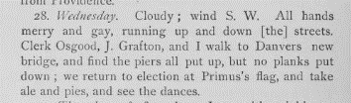





Citation and Credit: Pynchon, W., Oliver, F. E. (Fitch Edward). (1890). *The diary of William Pynchon of Salem.* Boston: Houghton, Mifflin and Co, 308-309. (https://hdl.handle.net/2027/uma.ark:/13960/t8w95bx85)

Diary of William Bentley

June 3, 1817

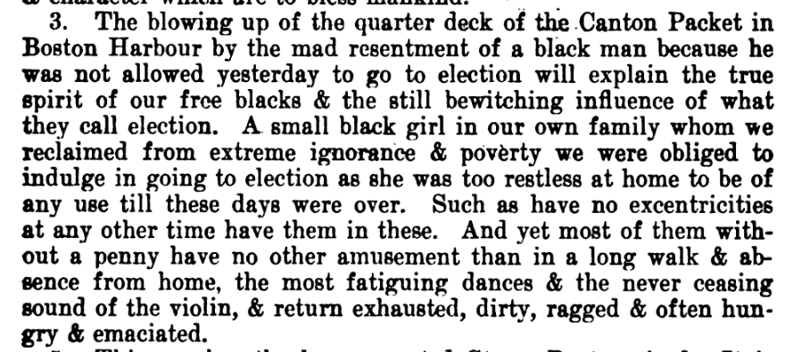

Citation and Credit: Bentley, W., Waters, A. G., Dalrymple, M., Waters, J. Gilbert., Essex Institute. (1905). *The diary of William Bentley, D. D..* Salem, Mass.: The Essex institute, 457. (https://hdl.handle.net/2027/yale.39002005662607)